## Criteria A

By: Yash Oza

Date: May 23, 2016

## The Problem

Bill Ritchie, the client, is the CEO of Thinkfun. *They have realised that there has been a decrease in the amount of students enrolling into mathematics and computer science, and want to reverse that by getting kids to enjoy the fields a little more.* They aim to do this by conducting math fairs which will incur problem solving, and motivate students into these specified fields. For now, they are concentrating on MYP students from grade 6 to grade 8, but if the outcome is positive, they will do the same for a larger age group.

Coincidently the target audience will be MYP students aged 6-8. Furthermore, Thinkfun’s Bill Ritchie wants to develop some free games for students to play at math fair (which is where I come in). These games should be motivational and should enhance a student’s problem solving skills, and hopefully from the games, students will be able to develop grit[1] and hard work.

If he succeeds, then Canada (at least) can have a more balanced economy, and Canada will be renowned as a more intelligent and scientific country. Also, students can develop positive problem solving skills that are required in their day to day lives, and they can have a well-rounded background to make informed decisions in the future (like stubbornness in life (in a moderated amount) is good, because it just means never giving up (like problem solving entails)). Thus the key stakeholders in this ‘experiment’ are teachers of mathematics (which will benefit from the teaching of problem solving), computer science groups (like code.org will see an increase in the amount of students that enroll in their programs), Thinkfun, Snap Math fairs, and also researchers looking at grit and willpower.

## Research Plan

Similar efforts to spark mathematical interest have been made in the past. An example of this are Snap Math fairs[2] and the mathematical touch it hopes to bring in the minds of students. Here teachers make students solve problems in a non-competitive manner, such that the students get inspired (almost alike the serendipity theory: one performs tasks unrelated to their job with the aim of building creativity (but here the task is related, but the students are having too much fun to realise)). They do this by researching and creating a problem, then on the day of the fair they walk around trying to solve their peer’s problem. For Thinkfun’s math fair, we can take the same essence of keeping the students involved in the project, while ensuring the problems are well-crafted by having professionals create the games (me) with some input beforehand.

The main factor that requires research is the drive that motivates students to choose their career path and what can influence it. But, as Angela Lee Duckworth[3] explains on Ted Talk, greatness cannot be influenced, it has to be chosen and requires a lot of hard work and dedication. Having taught math, she quickly realized that IQ wasn’t the only thing separating the successful students from those who struggled. It was simply how much they dedicated themselves. Her experience teaching these fields along with her speciality with grit, make her a credible source.

This topic was further addressed in a Freak-a-nomics podcast[4], where the speaker argues that there are no geniuses. One can become the best simply through practice as, “Grit is passion and perseverance for long term goals.” Furthermore, there are 4 key qualities that gritty people possess:

1. Interest
2. Practice
3. Purpose
4. Hope

Gladwell, in his book, “The Story of Success[5],” talks about how “talent is circumstantial, and it highly depends on the influence of peers. Also, motivation crushes criticism, and challenges drive originality.” This entire book is fairly similar to the idea of grit and self-confidence, while ensuring life is but a long problem that needs to be solved.

After all this research, it has become certain that one cannot make anyone gritty, they have to do that themselves. All one can do is lay a formidable foundation to allow the other to aspire for greatness; *alike the foundation these math fairs will provide for the MYP students.*

## Inspiration Pieces

Since grid games have been the ‘go-to’ style of games in these types of fairs, Thinkfun has decided it would not be appropriate to stray from it. So a big restriction will be to only look at grid-based games.

Also, whatever theme I choose, I will need to be sure that it relates to the tasks that will be present within the program. If not, then it will lead to player confusion, which discourages them in their efforts of problem solving. Furthermore looking at the target audience I will need to ensure the game is not that complex (like it cannot be an 18 by 18 game of Sudoku).

Cosmin Mihaiu[6], from Ted Talk had researched under this topic in the past and used various simple games to build motivation in the minds of autistic students. He has looked at this topic in regard to physical therapy as well. After doing so he came to the conclusion that playing games can motivate them, and from all the games, 3 by 3 and 4 by 4 grid games work the best. A simple game that he has looked at in the past that directly relates to problem solving was TicTacToe.

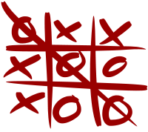[7]

He used the game to ‘root in’ the process of identifying problems and searching for a solution by the means of digitally getting a common row (3 x’s or 3 o’s). The end question from his studies is whether or not these game will be able to spark an interest for math and technology. Perhaps, a game with obvious mathematical calculations will be more appropriate, but the idea of a 3x3/4x4 game makes the search a lot narrower.

Apart from the previously mentioned Snap Math Fairs and how they have been used to enhance problem solving, I started focusing on 4 by 4 grid games, and stumbled upon a website with many games that teachers have used to build attentiveness amongst pre-school students[8]. Though it has a similar essence, the games here are not created by students, and in fact are grid games (like the specifications). Though they are completely childish and simple for the target audience, the idea is impressive. Here’s a simple matching game, where all similar animals have to line up in a line:

[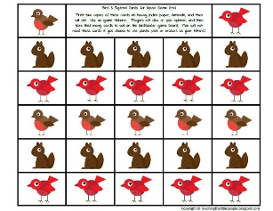](https://www.teacherspayteachers.com/Product/Tree-Math-Play-Dough-Mats-731418)(Image follows link above (8))

These sources opened my mind to realise some bad choices for the final goal. For example, minesweeper would not be the best choice for one of the math fair games because 1: the grid is too huge, and if the game is even resized to a 4 by 4 version, then it becomes too easy. At the same time, the game requires too much thinking, and moreover chance than problem solving (the way many people play it (by clicking randomly)). Also, the entire purpose of the fair is so the students enjoy, and as a result consider math and/or computer-science as a viable career choose. But if the game is confusing, the entire purpose is defeated.

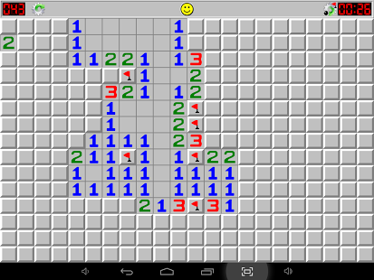 (Cropped screenshot)

So far in my search, the game 2048 seems to be the best choice as it involves numerical thinking, as there is a specific pattern that leads to victory. If the greater pieces are all put towards one corner, their addition process becomes easier and one can last longer though the game. Also there is a clear mathematical involvement that does not overshadow the simplicity of the game; resulting it to be really fun. Also it is highly rated at 4.5/5 by the Google play and the Apple store in terms of enjoyment.

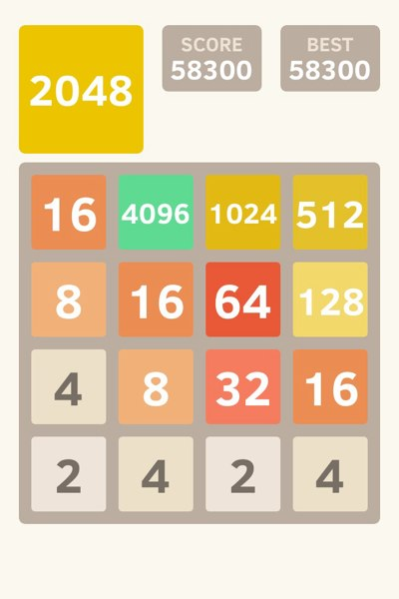 (Cropped screenshot)

## Specifications for the code

* There must be a grid game and/or puzzle
* There should be pieces for the players to move
* There should be comments for the code to be easily adaptable
* No animation
* Should be a winning condition and/or score
* There should be thinking and/or problem solving to complete the puzzle
* There must be a theme to make the problem more engaging (eg. League of Legends, Spongebob).
* Should be instructions
* Should follow Good UI design principles
* There should be color and pictures
* Pictures should be sourced at the top of code for copywriter purposes
* Multiple screens
* Widget should use set dimension so that there are a correct size if needed
* A new widget should be used (menu, checkbox, radio button, and progress bar)
* 500-2000 lines of code
* English
* Java
* Dell intel dual core computer that is 4 years old
* Screen: 1280 * 1024 pixels
* No scroll
* Screens should all be the same size

## Bibliography

* How to Get More Grit in Your Life - Freakonomics. (n.d.). Retrieved May 11, 2016, from http://freakonomics.com/podcast/grit/
* SNAP Mathfairs. (n.d.). Retrieved May 11, 2016, from http://www.mathfair.com/
* The key to success? Grit. (n.d.). Retrieved May 11, 2016, from https://www.ted.com/talks/angela_lee_duckworth_the_key_to_success_grit?nolanguage=en.
* How to Get More Grit in Your Life - Freakonomics. (n.d.). Retrieved May 11, 2016, from http://freakonomics.com/podcast/grit/
* Outliers: The Story of Success Summary - eNotes.com. (n.d.). Retrieved May 11, 2016, from http://www.enotes.com/topics/outliers-the-story-of-success

Physical therapy is boring -- play a game instead. (n.d.). Retrieved March 09, 2016, from https://www.ted.com/talks/cosmin_mihaiu_physical_therapy_is_boring_play_a_game_instead

(n.d.). Retrieved March 16, 2016, from https://en.wikipedia.org/wiki/Tic-tac-toe

* John, B. K. (n.d.). Math Grid Games. Retrieved May 11, 2016, from http://www.teachingthelittlepeople.com/the-big-picture-goals-of ecsped/preacademics/math-literacy/grid-games-in-preschool/

1. How to Get More Grit in Your Life - Freakonomics. (n.d.). Retrieved May 11, 2016, from http://freakonomics.com/podcast/grit/
2. SNAP Mathfairs. (n.d.). Retrieved May 11, 2016, from http://www.mathfair.com/
3. The key to success? Grit. (n.d.). Retrieved May 11, 2016, from https://www.ted.com/talks/angela_lee_duckworth_the_key_to_success_grit?nolanguage=en.
4. How to Get More Grit in Your Life - Freakonomics. (n.d.). Retrieved May 11, 2016, from http://freakonomics.com/podcast/grit/
5. Outliers: The Story of Success Summary - eNotes.com. (n.d.). Retrieved May 11, 2016, from http://www.enotes.com/topics/outliers-the-story-of-success
6. Physical therapy is boring -- play a game instead. (n.d.). Retrieved March 09, 2016, from https://www.ted.com/talks/cosmin_mihaiu_physical_therapy_is_boring_play_a_game_instead
7. (n.d.). Retrieved March 16, 2016, from https://en.wikipedia.org/wiki/Tic-tac-toe
8. John, B. K. (n.d.). Math Grid Games. Retrieved May 11, 2016, from http://www.teachingthelittlepeople.com/the-big-picture-goals-of ecsped/preacademics/math-literacy/grid-games-in-preschool/